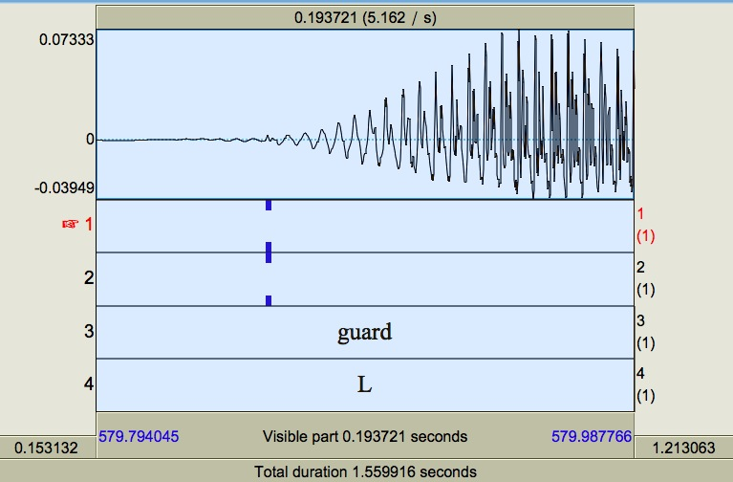
It seems like she did not pronounced /g/ here – only vowels. I could not hear /g/.

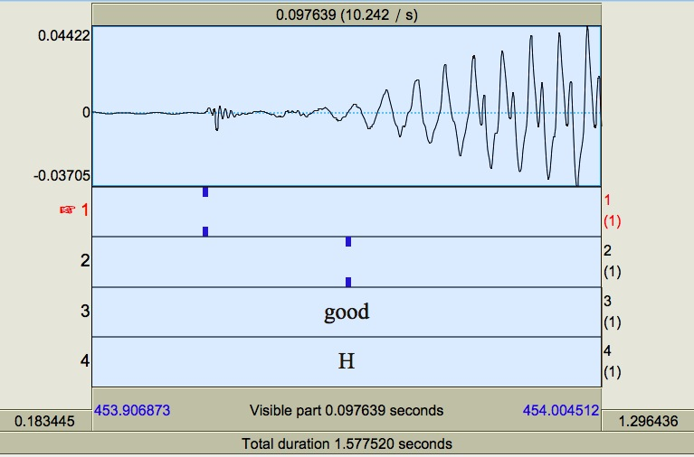
I think here she is saying /k/ instead of /g/ (there other instances like this), in which I think she is devoicing /g/.

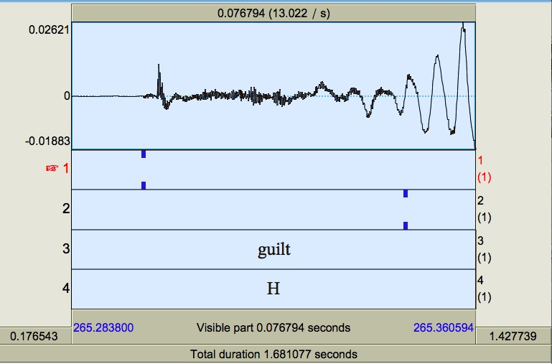
Here it is a long aspiration for /k/, right? She devoiced it.

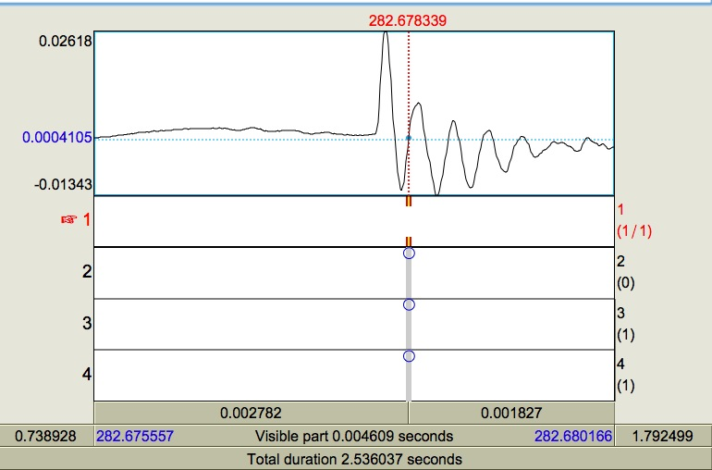
I am cutting from the first up zero crossing. What about in a case like this? Should I cut only at zero crossing, or should I cut it before?
Thank you, Miquel!

